

Pratik | Web Design and User Experience | December, 2015

Dating/Social Networking Website Report

Summary: This Project is about creation of Dating/Networking website. Have used jquery for input fields validations and HTML5 for some fields. Have implemented bootsrap, Jquery, Java Script, HTML, HTML5 and Ajax.

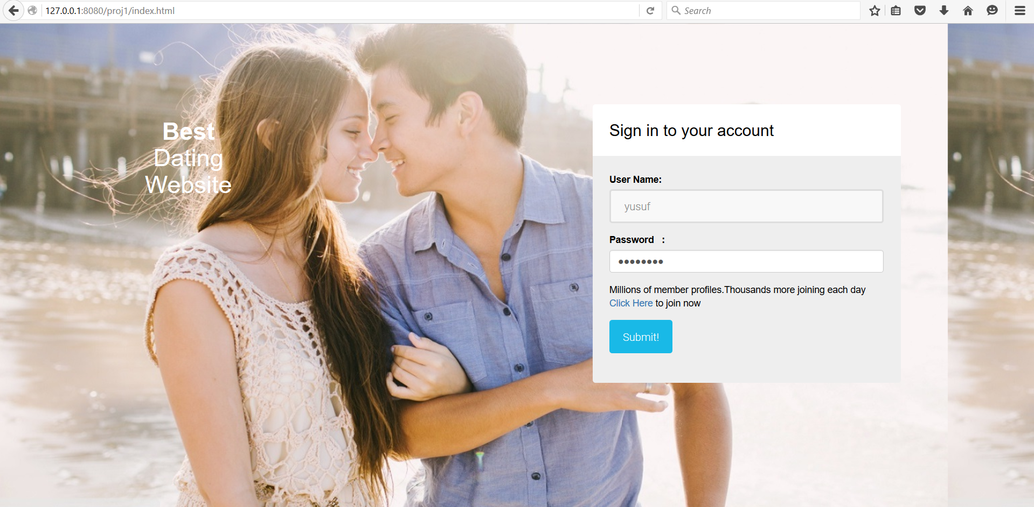

Home Page :

Notes : Implemented this page using bootstrap and validated the input fields using jQuery

Code : index.html

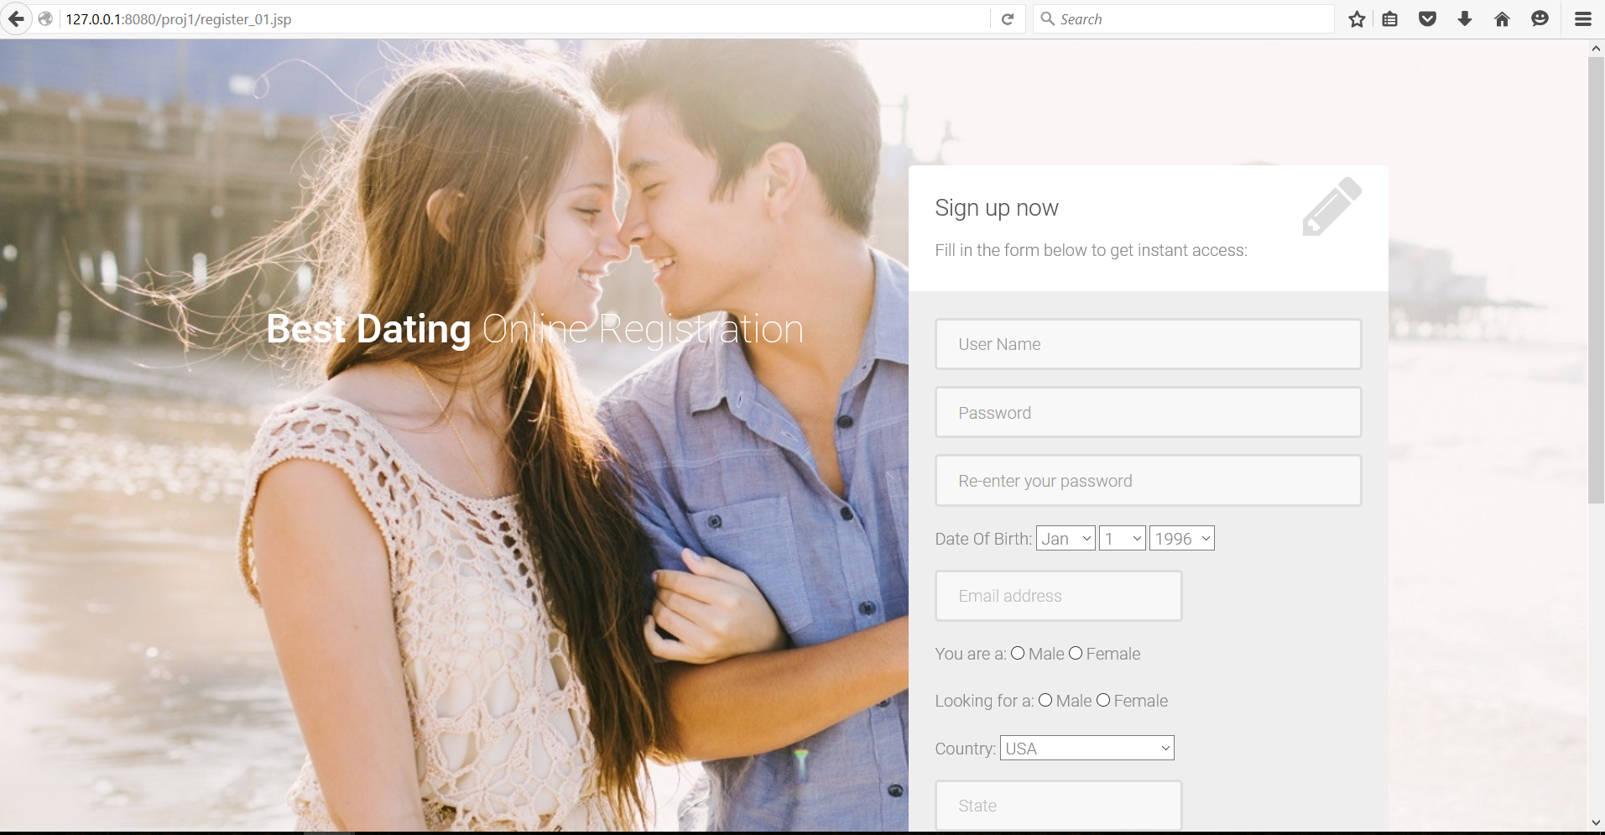

When user Clicks on Signup Page, the above mentioned page appears

Implemented this page using bootstrap which is responsive and also performed the field validations using JQuery.

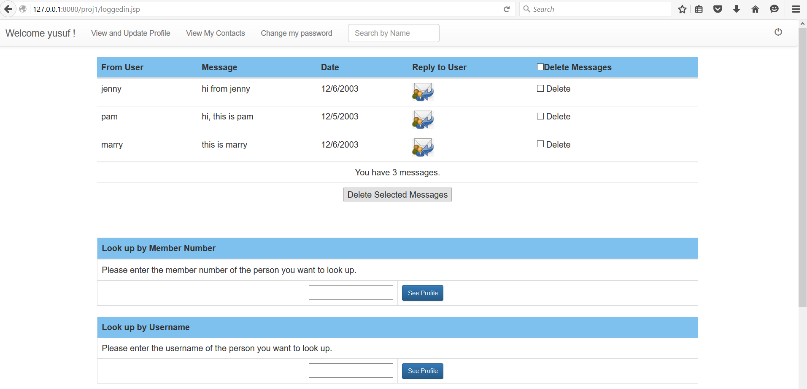

Login Home Page :

The page has been designed using bootstrap .

The user can navigate to all the pages to view his details and update them accordingly

Implemeneted Ajax Functionality for lookup by Member Number

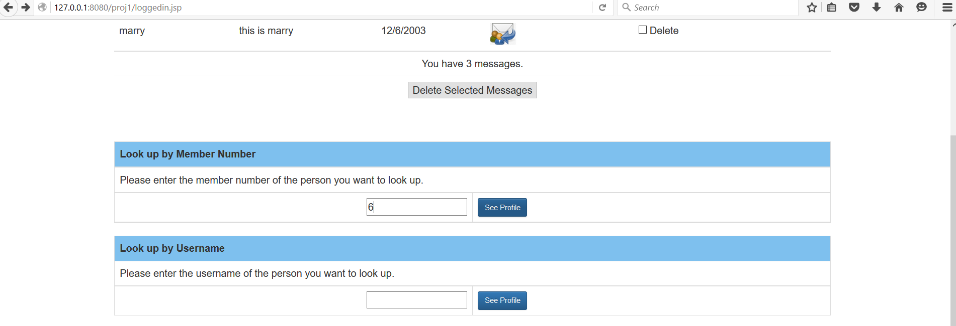

The information is displayed on the same page without the page getting refreshed.

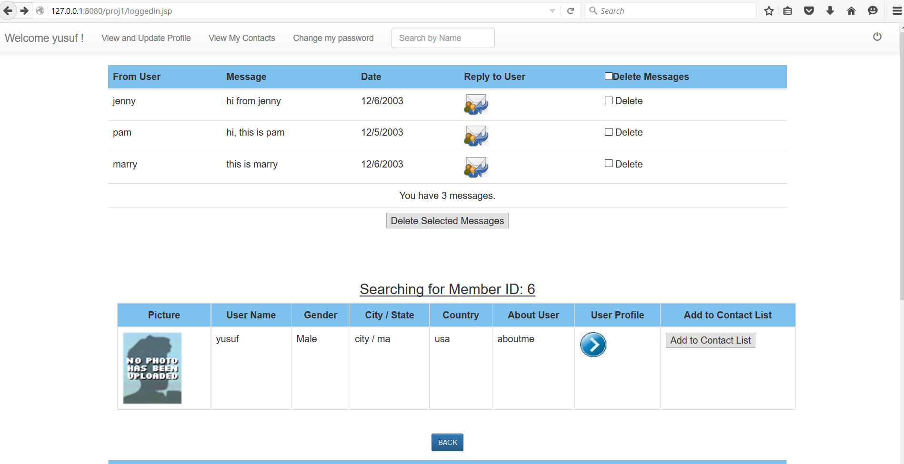

Viewing Contact Details :

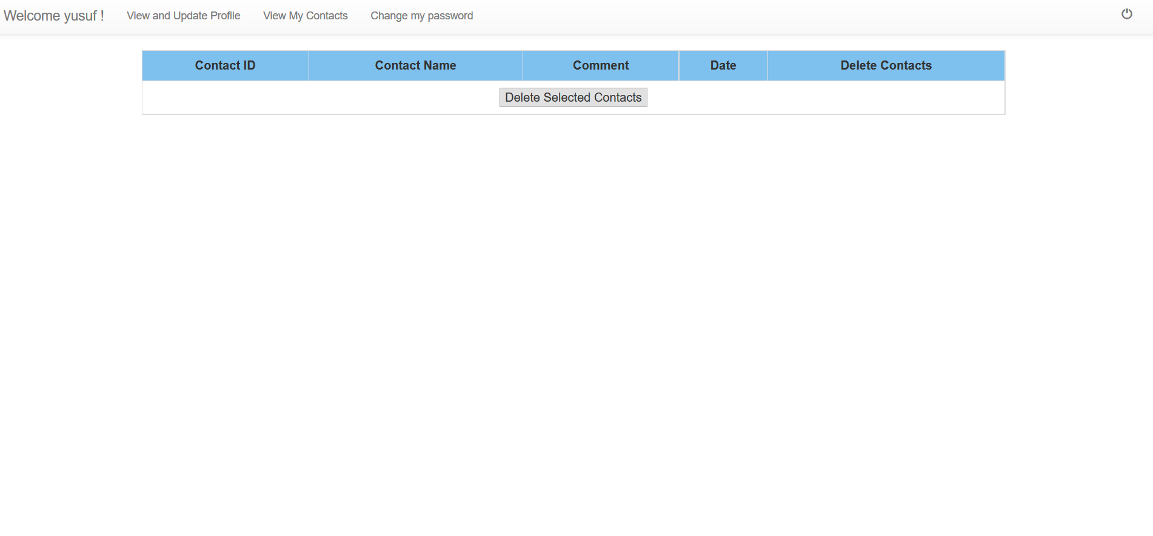

Change Password : 